Face Sentiment Detection

Yassine Maatougui

# 1. Project Inception

## 1.1. Framing the Business Idea as an ML Problem (milestone 1, 5%)

* **Business case description:**

The project aims to develop a Face Sentiment Detection system capable of identifying and analyzing facial expressions to detect emotions. This technology can be applied in various sectors such as customer service, security, and healthcare to enhance user interactions and emotional assessments.

* **Business value of using ML:**

By employing machine learning, we can automate the recognition of facial emotions with high accuracy, which is crucial for real-time applications. This reduces the need for manual interpretation and allows for quicker and more efficient decision-making processes in professional settings.

* **Data overview:**

The project utilizes a comprehensive dataset consisting of images labeled with eight distinct emotions. This dataset helps in training the model to accurately recognize and classify different facial sentiments.

* **Project archetype:**

This is a classification problem where the model predicts the type of emotion based on facial features extracted from images.

## 1.2. Feasibility analysis

* **Literature review:**

Reviewed various models from the TensorFlow 2 Detection Model Zoo and the yolov8-emotions model, which are renowned for their efficiency in object detection tasks. The selection was based on their performance metrics in similar tasks outlined in the model zoo documentation [TensorFlow 2 Detection Model Zoo](https://github.com/tensorflow/models/blob/master/research/object_detection/g3doc/tf2_detection_zoo.md).

* **Model choice/ specification of a baseline:**

Chose a robust model from the TensorFlow 2 Detection Model Zoo for initial benchmarking due to its pre-trained capabilities on similar image data, providing a solid baseline for performance comparison.

* **Metrics for business goal evaluation:**

The primary metrics for evaluating the business goals are accuracy, processing speed, and the model's adaptability across various environments and demographic groups.

# 2. ML Pipeline Development - From a Monolith to a Pipeline

## 2.1. Ensuring ML Pipeline Reproducibility (milestone 2, 15%)

* **Project structure definition and modularity:**

The ML pipeline is structured for modularity using TFX components to separate data handling, model training, and evaluation processes.

For installing TFX, I have used Anaconda:

* Installation of TFX using Miniconda:

1. Firstly, I have installed miniconda3 from their official website.
2. Then, I created an environment for my project using the command:

conda create - - name tfx python=3.9

conda activate tfx

1. After that I installed tfx: pip install tfx==1.15.0 tensorflow==2.15.1
2. Now, I was able to use tfx library and it gives me this result:

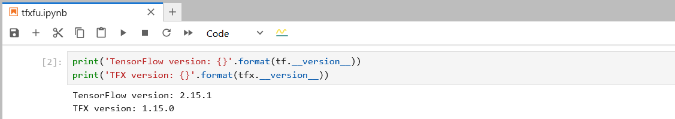

* However, I still had an issue when I wanted to use the Object Detection library. Therefore, I went to the tfx library, which I installed it using the previous commands and I changed the function ‘preprocessing_fn’. Under that function there is a function named ‘scale_input(inputs)’. On this function I have added these lines of code:  
   image = tf.image.decode_jpeg(inputs, channels=3)

image = tf.image.resize(image, [600, 600])

return image

For creating the Pipeline:

Command used: “tfx pipeline create --pipeline-name=my_face_sentiment_detection_pipeline --pipeline-root={PIPELINE_ROOT} --endpoint={ENDPOINT}”

* On my Github repository, you can find the script that contains the whole pipeline and it is named “tfxfu.ipynb” in the root folder.

* **Code versioning:**

Using Git hosted on GitHub for version control allows meticulous tracking of all changes throughout the development cycle, enhancing transparency and collaboration.

Git commands for versioning:

git init  
git add .  
git commit -m "Initial commit"

* **Data versioning:**

Data Version Control (DVC) manages dataset changes systematically, maintaining data integrity and ensuring reproducibility across different pipeline stages.

DVC commands used to track data versions:

dvc init  
dvc add data/dataset  
git add data.dvc .gitignore  
git commit -m "Add dataset with DVC"

* **Experiment tracking and model versioning:**

The Metadata Store in TFX is used for tracking experiments and managing model versions, providing detailed insights into model performance and version history.

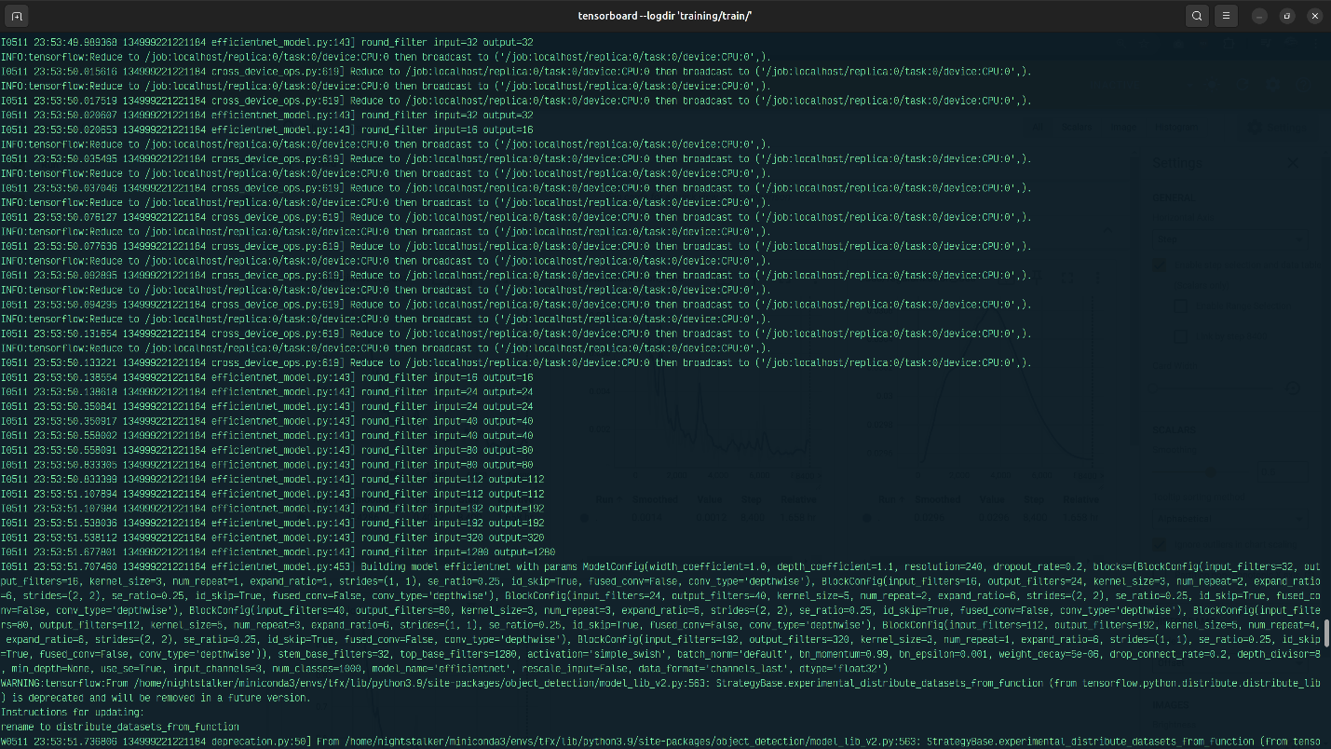

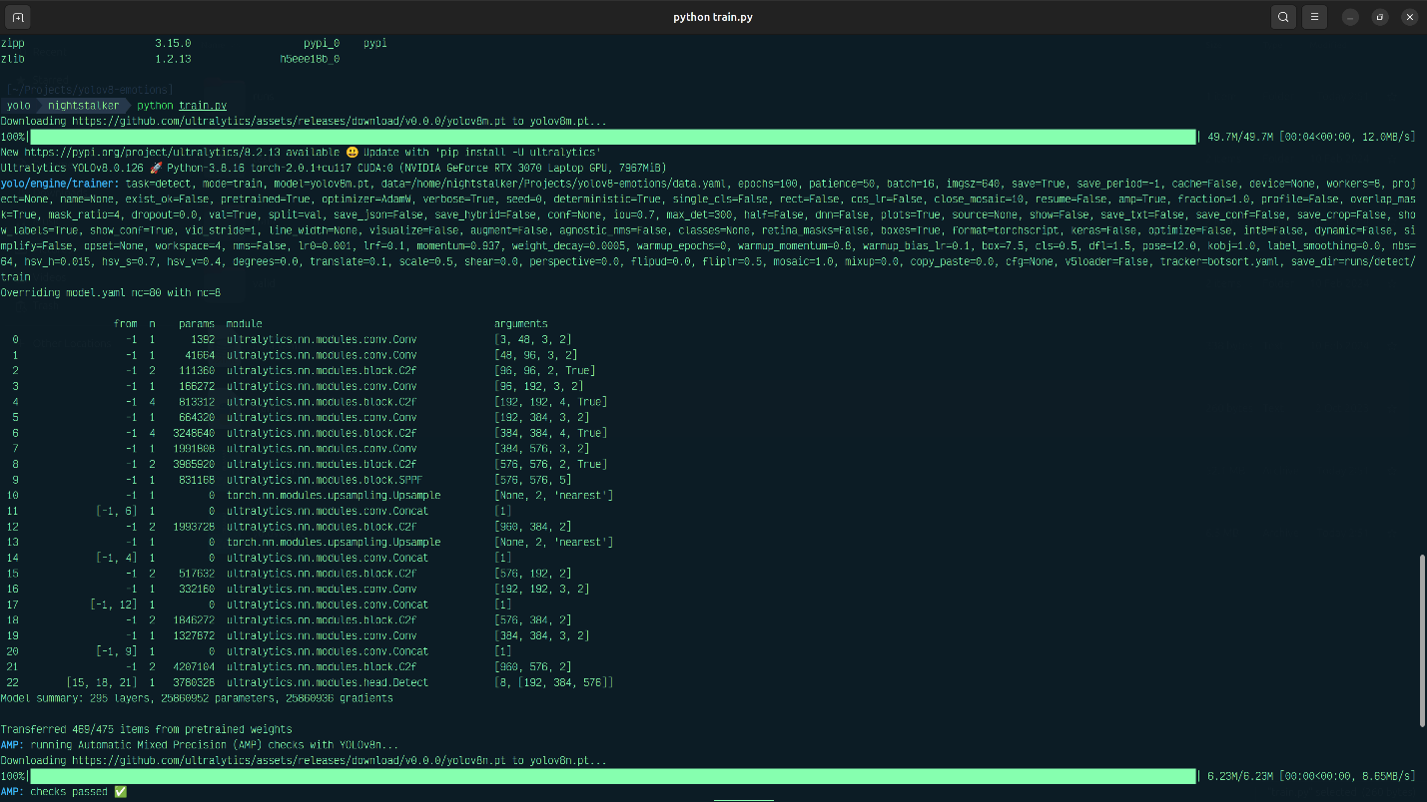

* **Setting up a meta store for metadata:**

TFX’s ML Metadata is used to store metadata about experiments, model training, and evaluation processes.

* **Setting up the machine learning pipeline under an MLOps platform:**

The entire ML pipeline is configured and managed using TFX, facilitating continuous integration and deployment practices.

## 2.2. Pipeline Components (Milestone 3 and 4, 20%)

1. **Setup of data pipeline within the larger ML pipeline/ MLOps Platform** 
   * **Data Validation and Verification:**

TFX Example Validator ensures data quality by comparing data statistics against a schema that describes expectations about data.

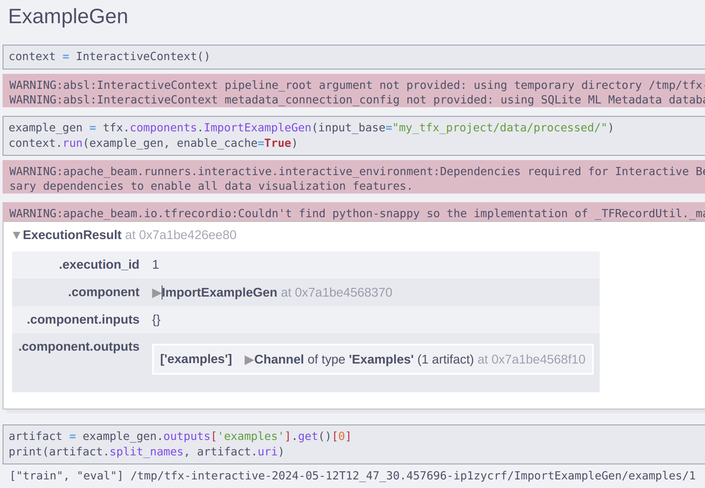

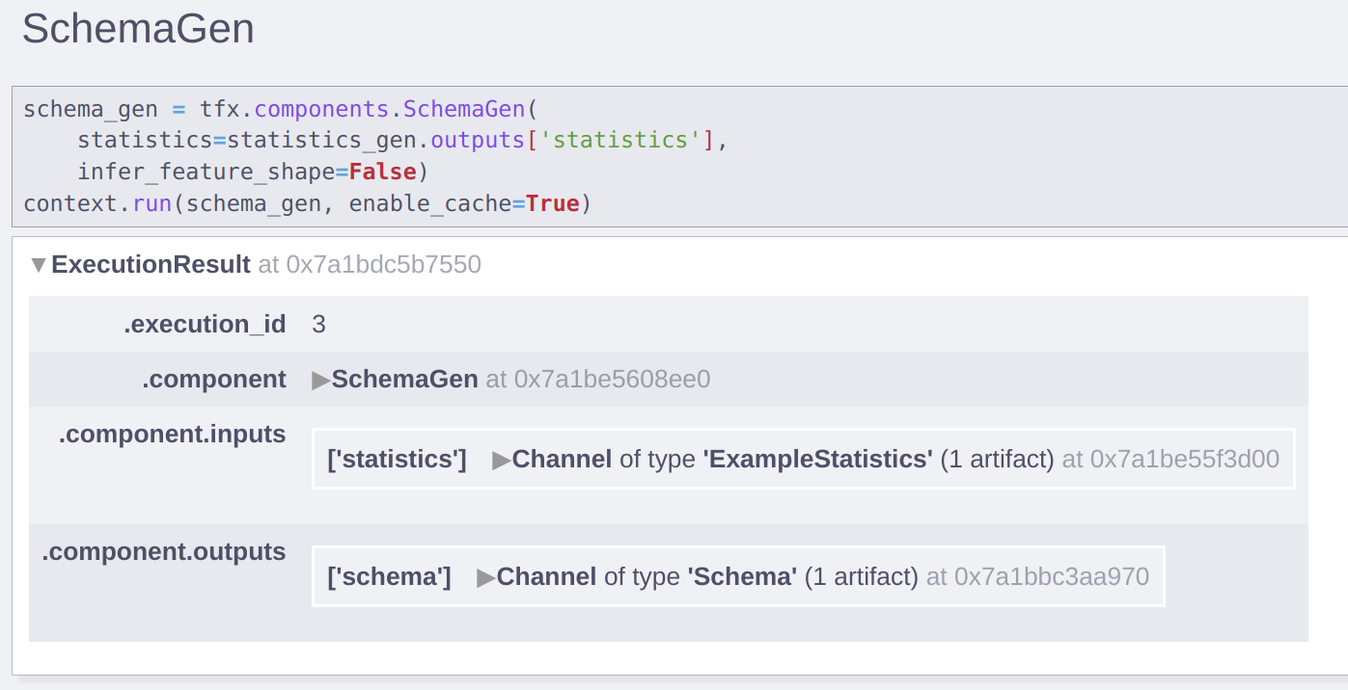

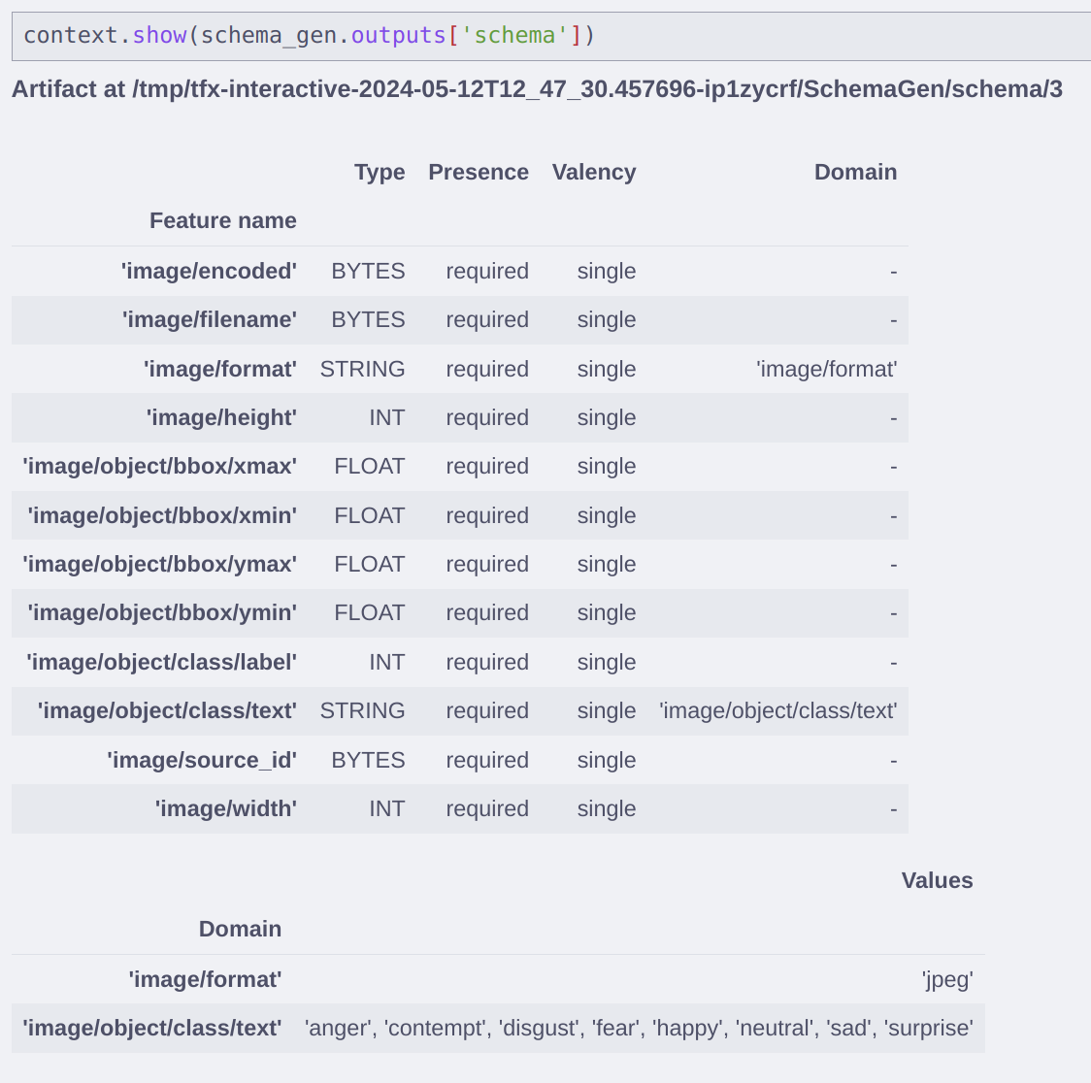

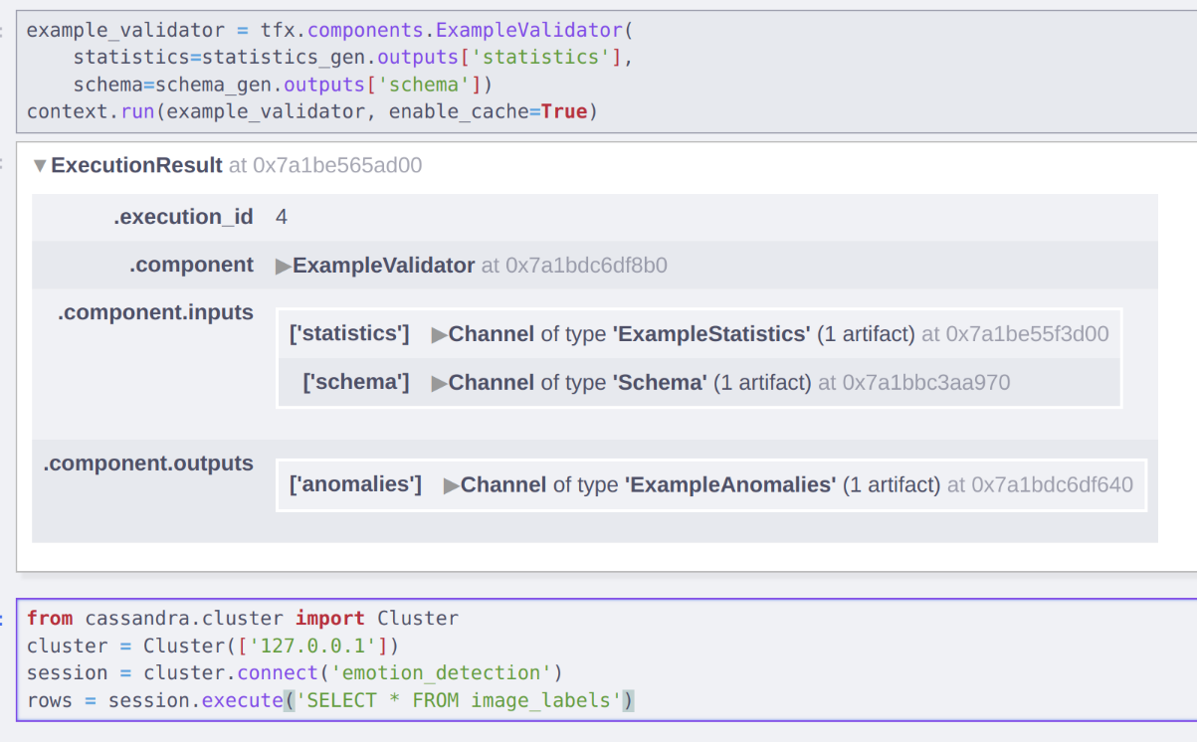

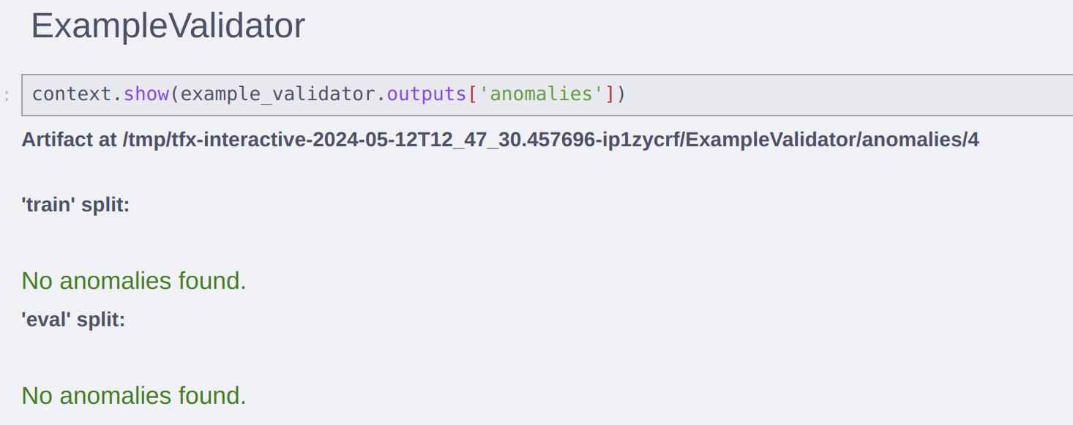

* + **Preprocessing and Feature Engineering:**

TFX Transform component is used for data preprocessing and feature engineering, ensuring that data is in the correct format for training.

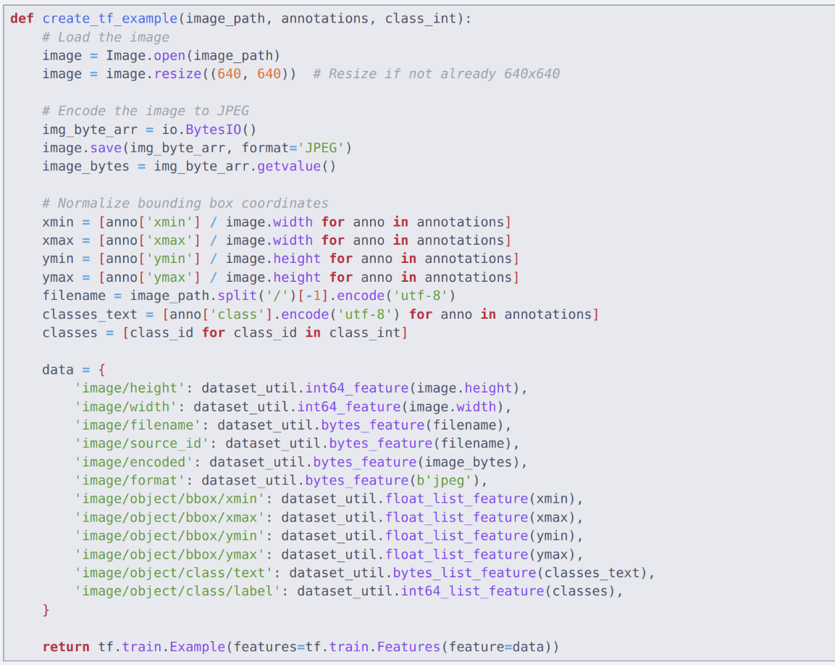

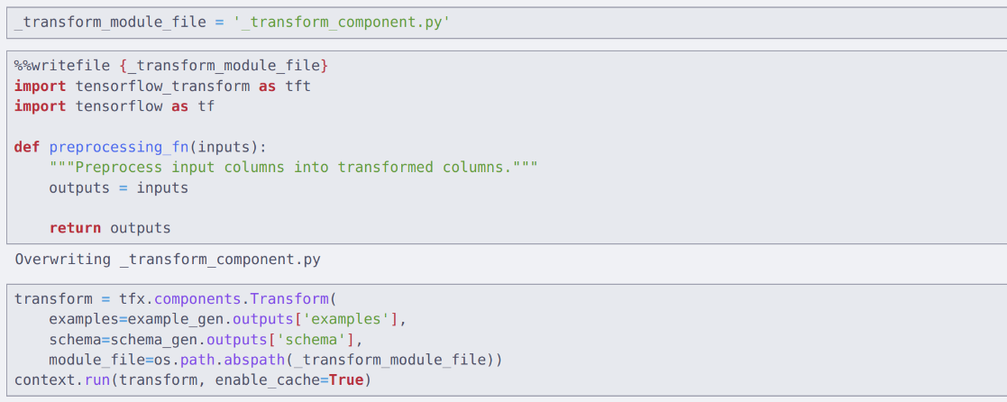

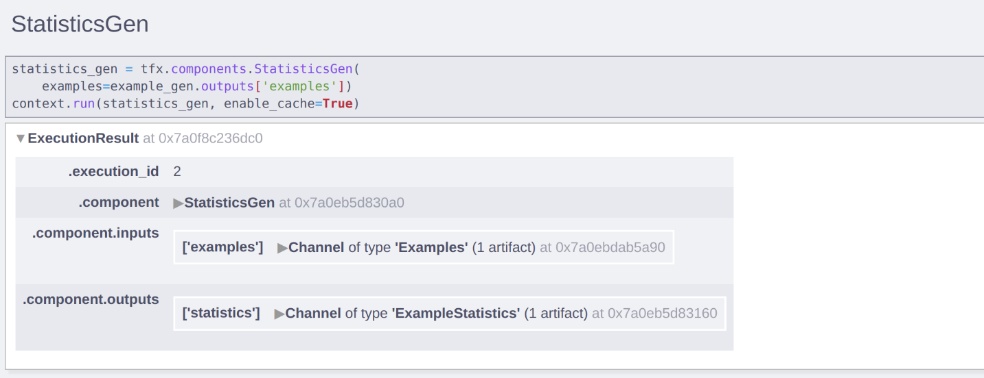

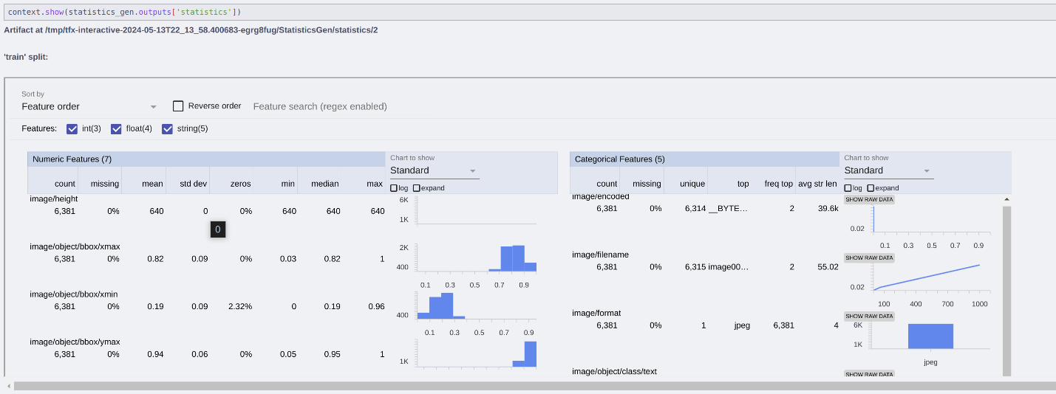

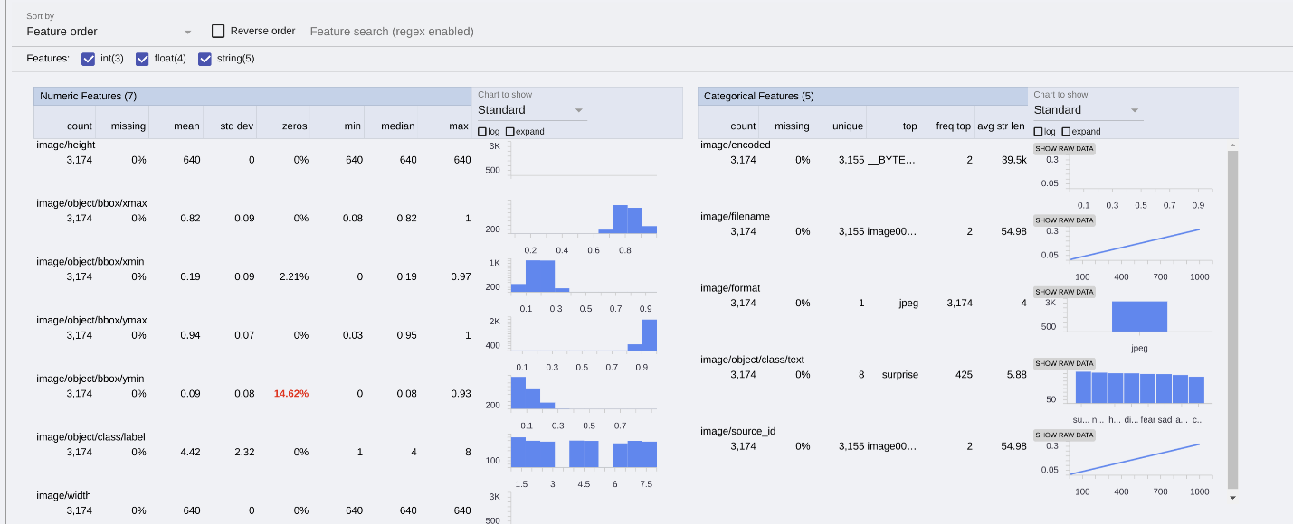

1. **Integration of model training and offline evaluation into the ML pipeline / MLOps Platform**

TFX Trainer and Evaluator components are integrated for model training and performance evaluation, ensuring the model is trained and assessed rigorously before deployment.

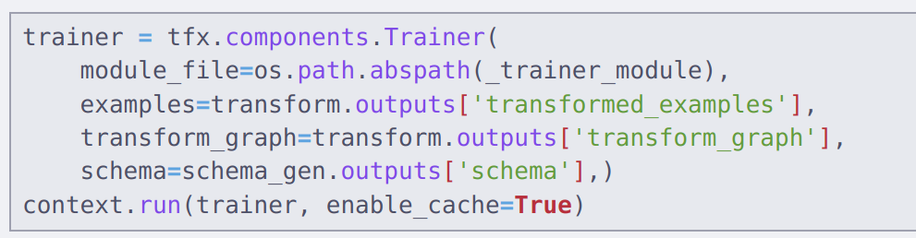

**Result:**

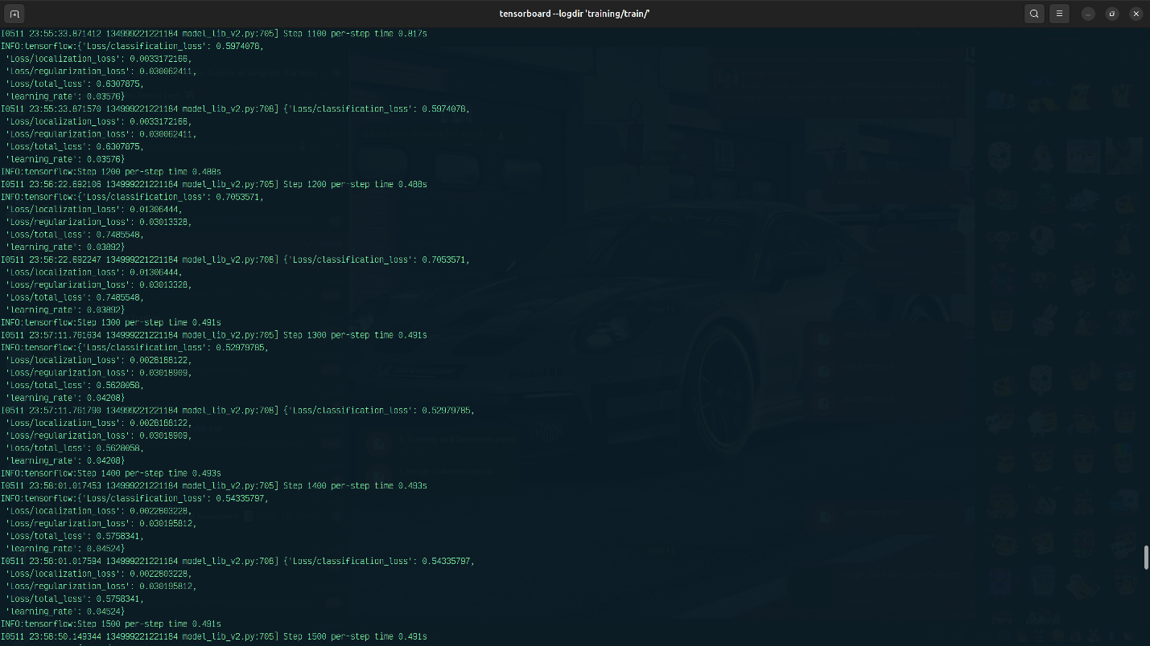

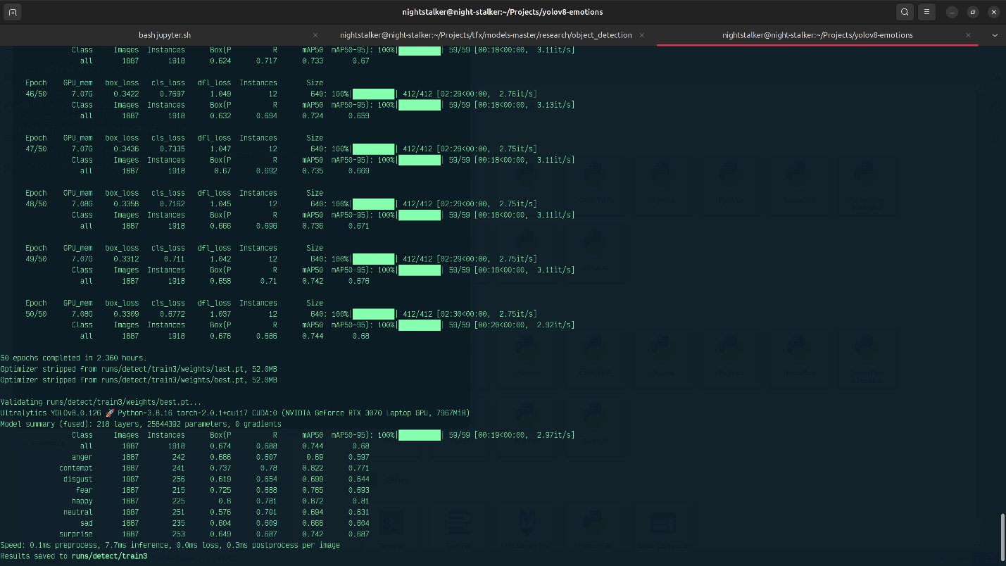

1. **Development of model behavioral tests**

Behavioral tests are designed to verify the model's functionality and performance under various conditions, ensuring robustness and reliability. I’ve used the library pytest for this step.

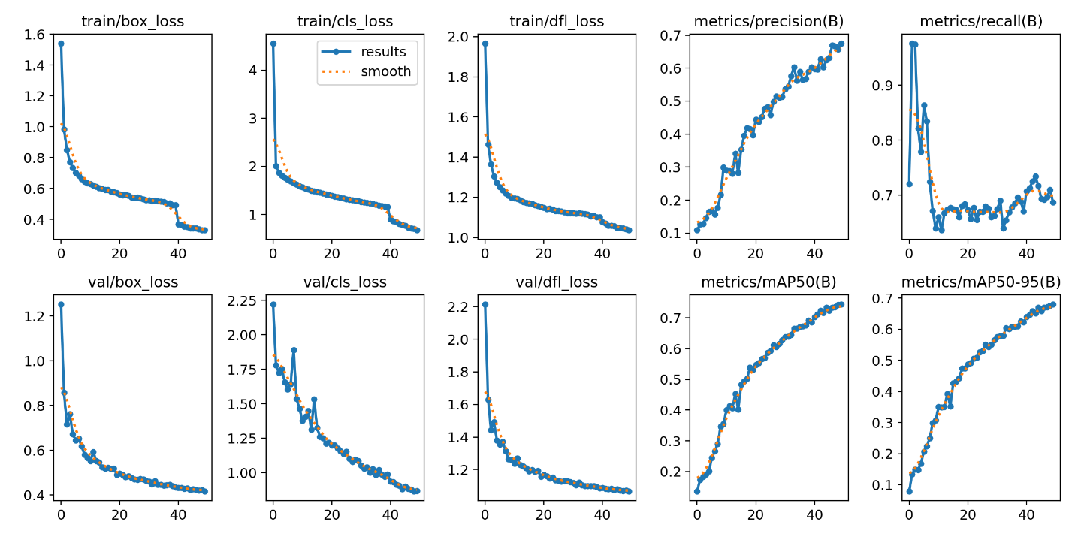

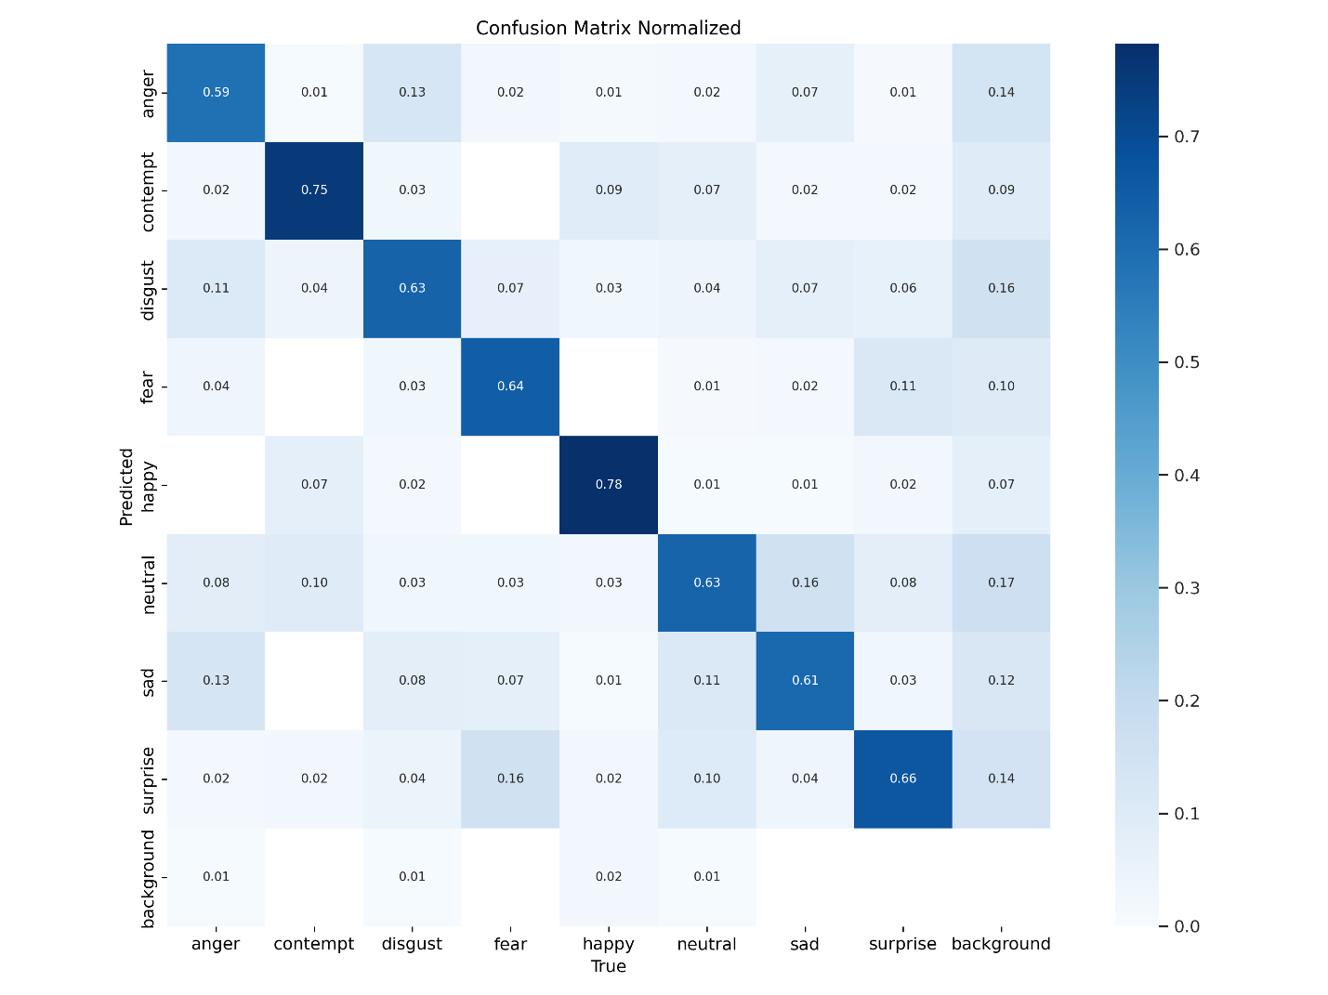

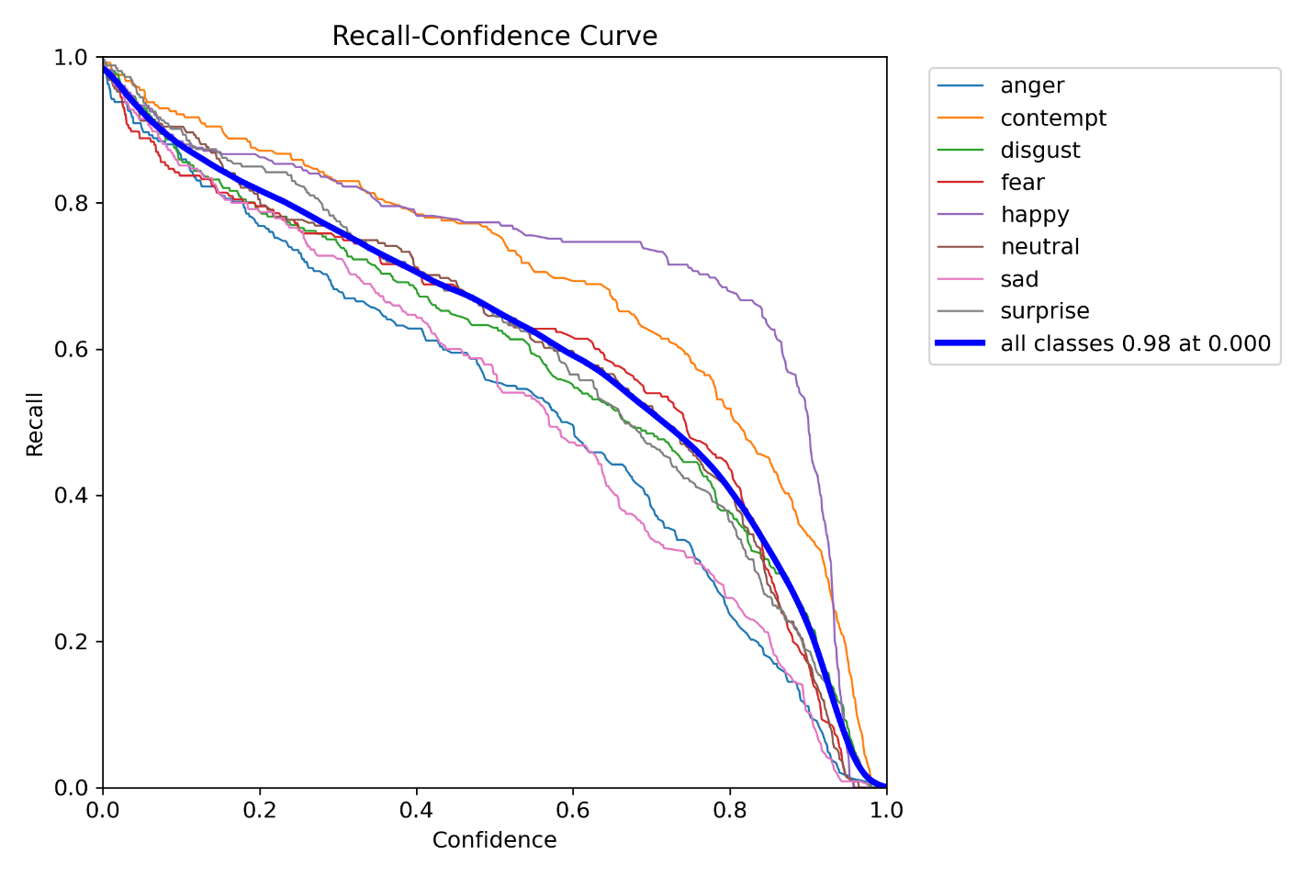

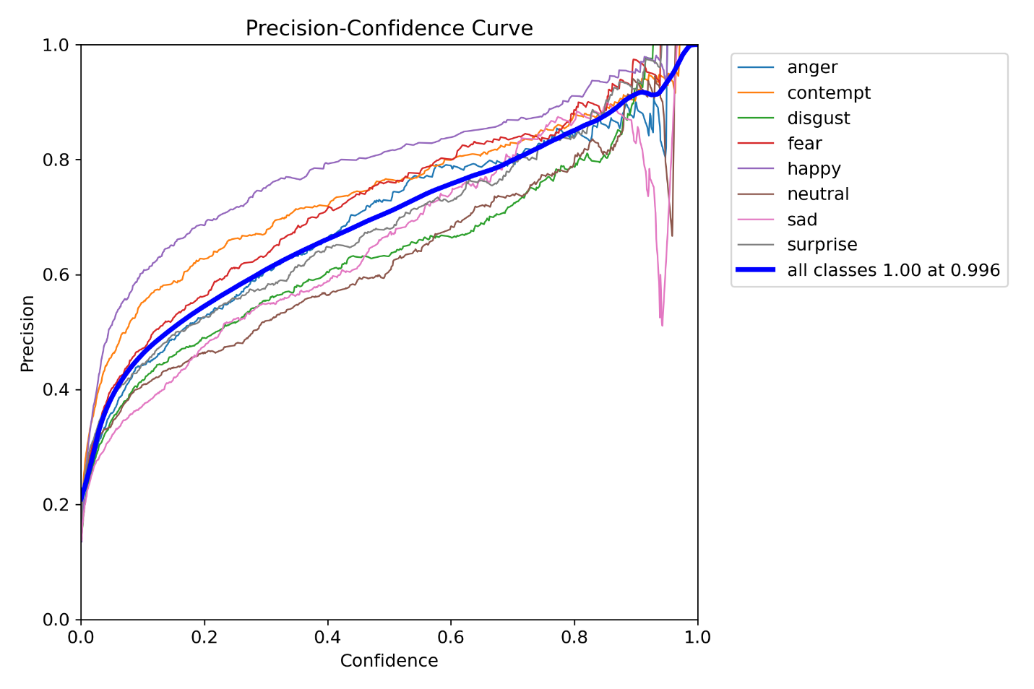

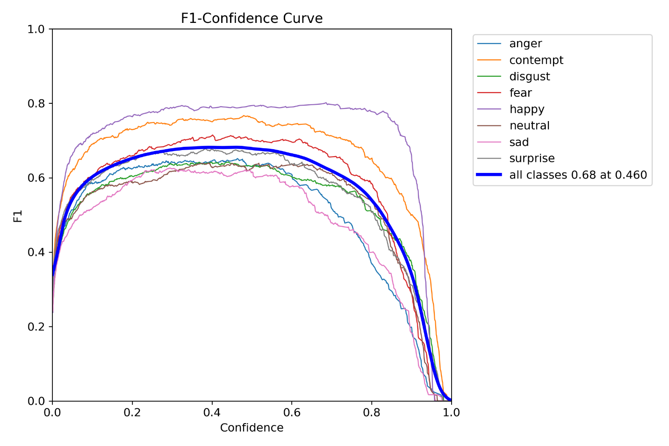

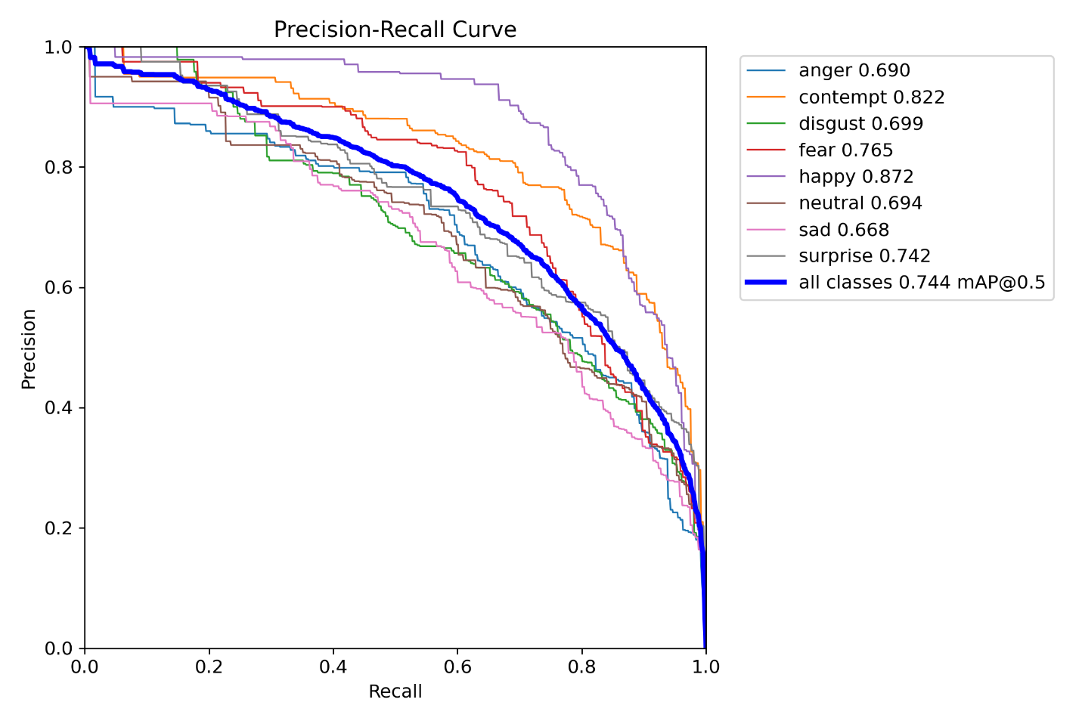

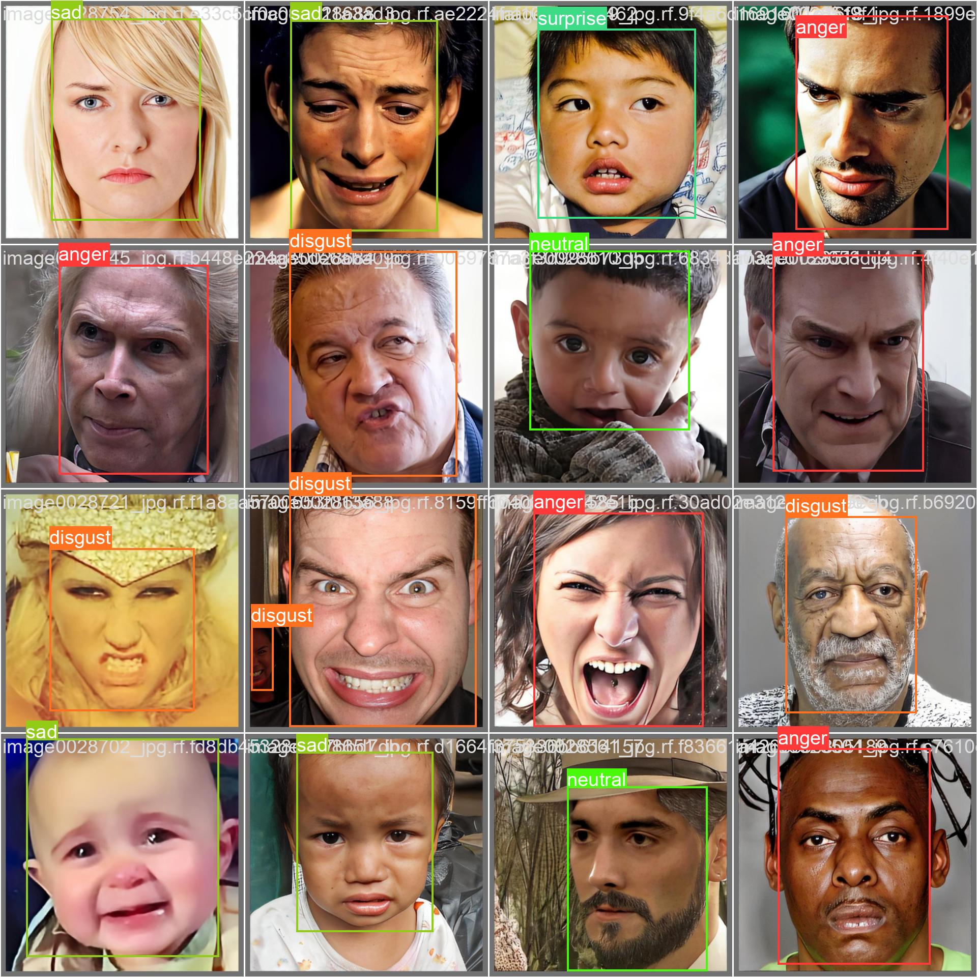

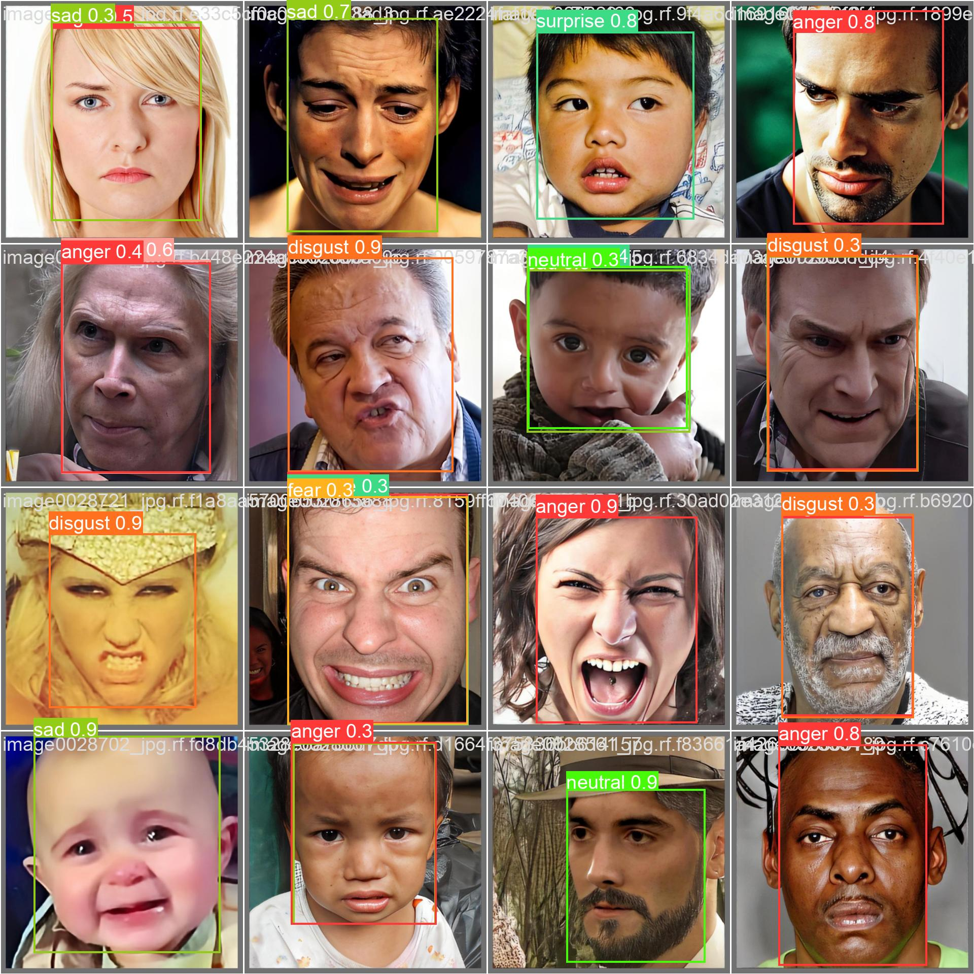

1. **Energy efficiency measurement**

Monitors and measures the model's energy consumption during training and inference to assess and optimize the system's energy efficiency.

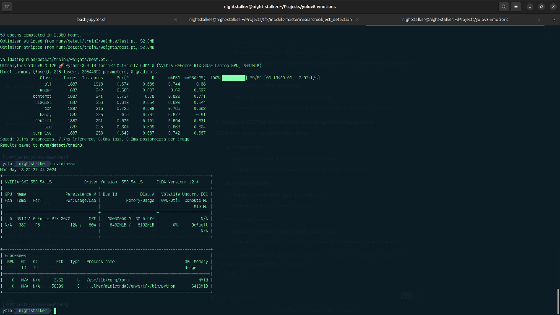

# 3. Model Deployment (Milestones 5-6, 35%)

## 3.1 ML System Architecture

* **Drawing with architecture highlights:**

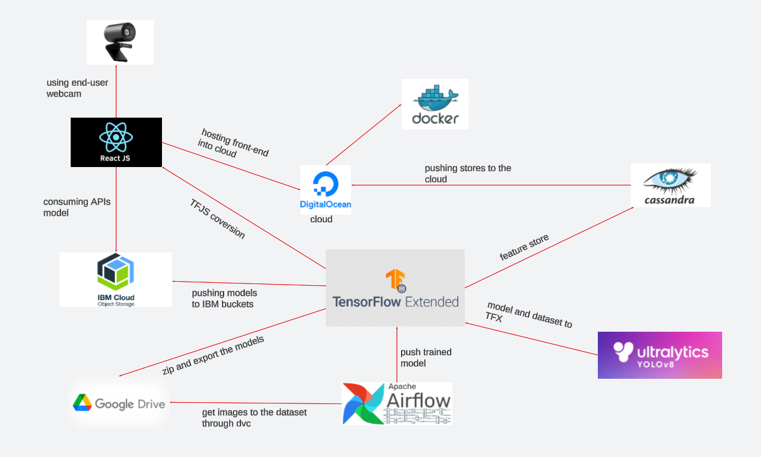

## 3.2 Application development

* **Model service development:** 
* **Front-end client development:**

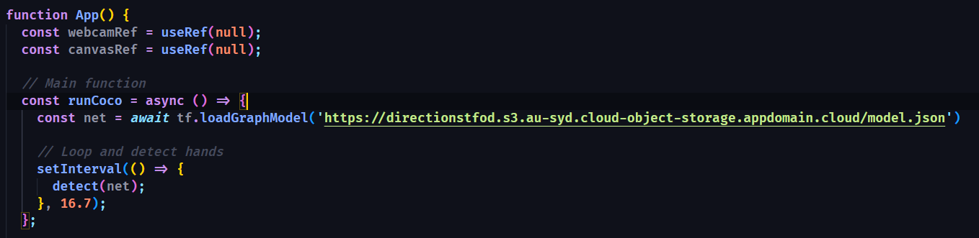

## 3.3 Integration and Deployment

* **Packaging and containerization:**

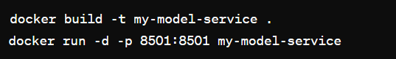

* **Integration with a CI/CD Pipeline:**

The CI/CD framework, orchestrated with GitHub Actions, is in the deepest of this structure. Running at every single update in data or change in the code base, this automated pipeline will trigger all the related workflows. For orchestration of the various tasks, rebuilding of Docker containers automatically, in case of changes in dependencies, pushing in a registry of the said containers, and deployment in production, the GitHub Actions will be utilized. This integration is key to ensure that the least possible downtime is incurred and that the model benefits from continuous updates with as little human intervention as possible.

TFX is the project's machine learning backbone, from data ingestion with ExampleGen down to model validation and serving with components such as Evaluator and Pusher. Each of the TFX components is designed within data transformation, model training, and deployment in a clear, reproducible way across environments, which is enforced by containerization in Docker.

In addition, Docker makes TFX even more robust as it wraps each component in a separate container, hence managing dependencies and configurations with simplicity. Furthermore, this scaling in deployment will also lead to isolation of processes, hence increasing safety and stability in the machine-learning pipeline. In essence, orchestration between TFX, Docker, and GitHub Actions is a best practice in MLOps that presents the way forward for the realization of a resilient, scalable, and sustainable infrastructure toward pushing machine learning models. It's a strategic way to achieve model adaptation and improvements in productions while keeping up with the principles of agility and excellence in machine learning deployments.

* **Hosting the application:**

I have hosted the application on Digital Ocean:

 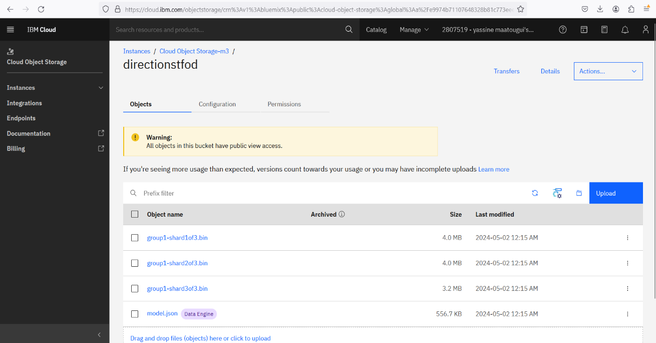

## 3.4. Model Serving and online testing

* **Model serving runtime:**

The model is served using TensorFlow Serving, which is optimized for both high performance and high availability. TensorFlow Serving provides out-of-the-box support for serving ML models, handling requests in real-time with low latency. It's set up to automatically load new versions of the model as they are trained and pushed to the serving directory, ensuring that the most accurate and up-to-date model is always in use.

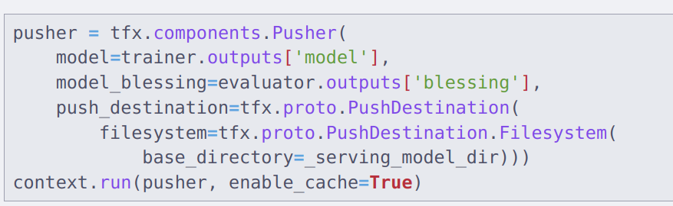

* **Serving mode (batch, on demand to a human, on demand to a machine):**

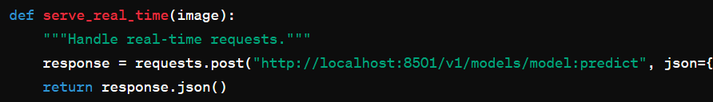

* **Online testing (A/B Testing, Bandit):**



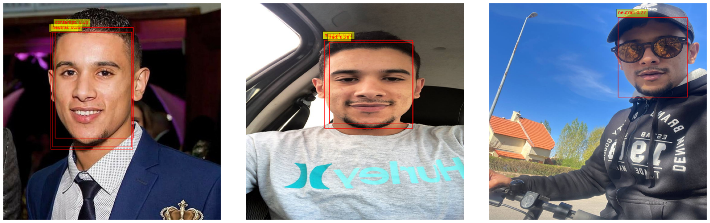

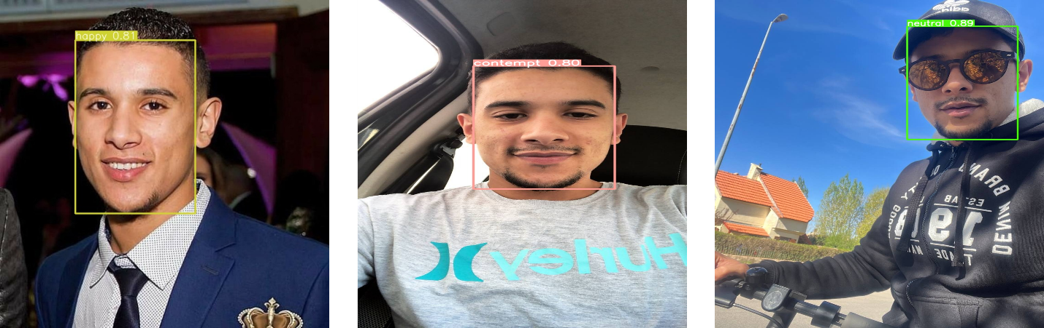

1. **Detection Quality**:

* **TensorFlow Object Detection API**: While it provides good detection within its targeted areas (upper face), it may generate multiple bounding boxes that can complicate the output, especially in scenarios needing streamlined and minimal error processing. This could impact its performance negatively if the goal is clear and singular detection per face.
* **YOLOv8 Detection**: It consistently delivers high-quality detections with a single bounding box per face, closely matching the ground truth. This reliability makes it preferable in applications where accurate full-face detection is critical, such as in security systems or comprehensive emotion analysis.

1. **Model Robustness**:

* Since YOLOv8 provides close-to-ground truth detection without multiple bounding box issues, it suggests greater robustness in varied real-world conditions compared to TensorFlow, which might struggle with overlapping or closely situated faces.

1. **Potential for False Positives/Negatives**:

* The TensorFlow model, due to its tendency to create multiple bounding boxes, might have a higher rate of false positives. This is important in scenarios where precision is more crucial than recall.
* YOLOv8, with its single, accurate bounding box approach, likely exhibits fewer false positives and negatives, providing more reliable results overall.



# Monitoring and Continual Learning (milestone 7, 25%)

## 4.1. (2 pts) Resource Monitoring

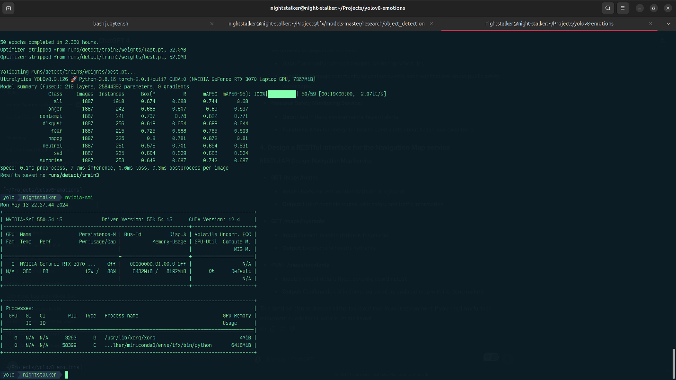

* To calculate the energy consumed:

Since power is typically calculated in watts (Joules per second), we need to convert the time from hours to seconds. Then, we multiply the power usage by the time in seconds to get the total energy in Joules.

Given:

$$Power (P) = 80 watts$$

$$Time (T) = 2.36 hours$$

Conversion:

$$Time in seconds = ( 2.36 ×3600 ) seconds/hour = 8496 seconds$$

Energy Consumption:

$$Totalenergy\left(E\right)=Power×Time=(80 \text{watts}×8496 \text{seconds})$$

Calculate the Total Energy:

$$E=80 \text{W}×8496 \text{s}=679,680 \text{Joules}$$

This is the energy consumed in Joules. If we wish to convert this into more common energy billing units like kilowatt-hours (kWh), you can use the $conversion(1 \text{kWh}=3,600,000 \text{J})$.

Conversion to kWh:

$$\text{kWh}=\frac{679,680 \text{J}}{3,600,000 \text{J}\text{/}\text{kWh}}≈0.189 \text{kWh}$$

Thus, we consumed approximately 0.189 kWh of energy during the training session.

Cost Calculation:

If you want to know how much this cost, you'd multiply the kWh by the cost per kWh from your local utility provider. For example, if the cost is $0.12 per kWh:

$$\text{Cost}=0.189 \text{kWh}×0.12 \text{per kWh}=0.023$$

## 4.2. (10 pts) Model Performance Monitoring or data distribution drift monitoring

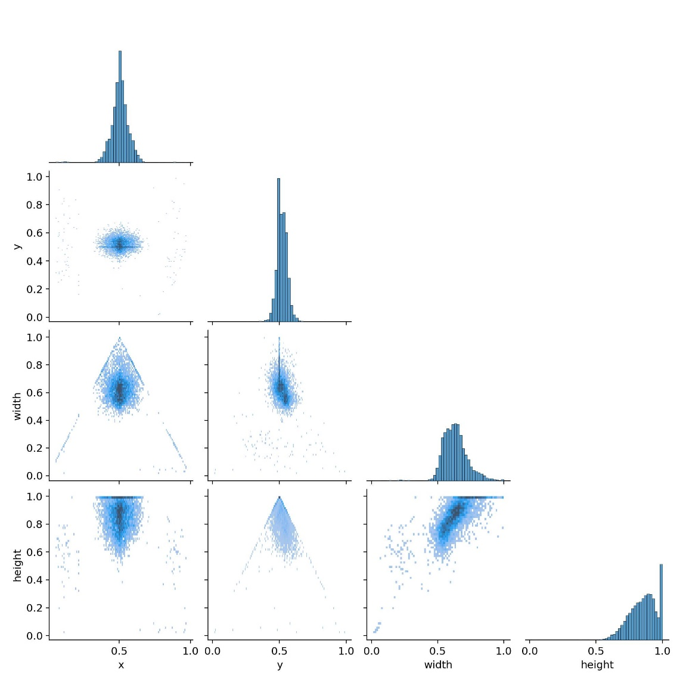

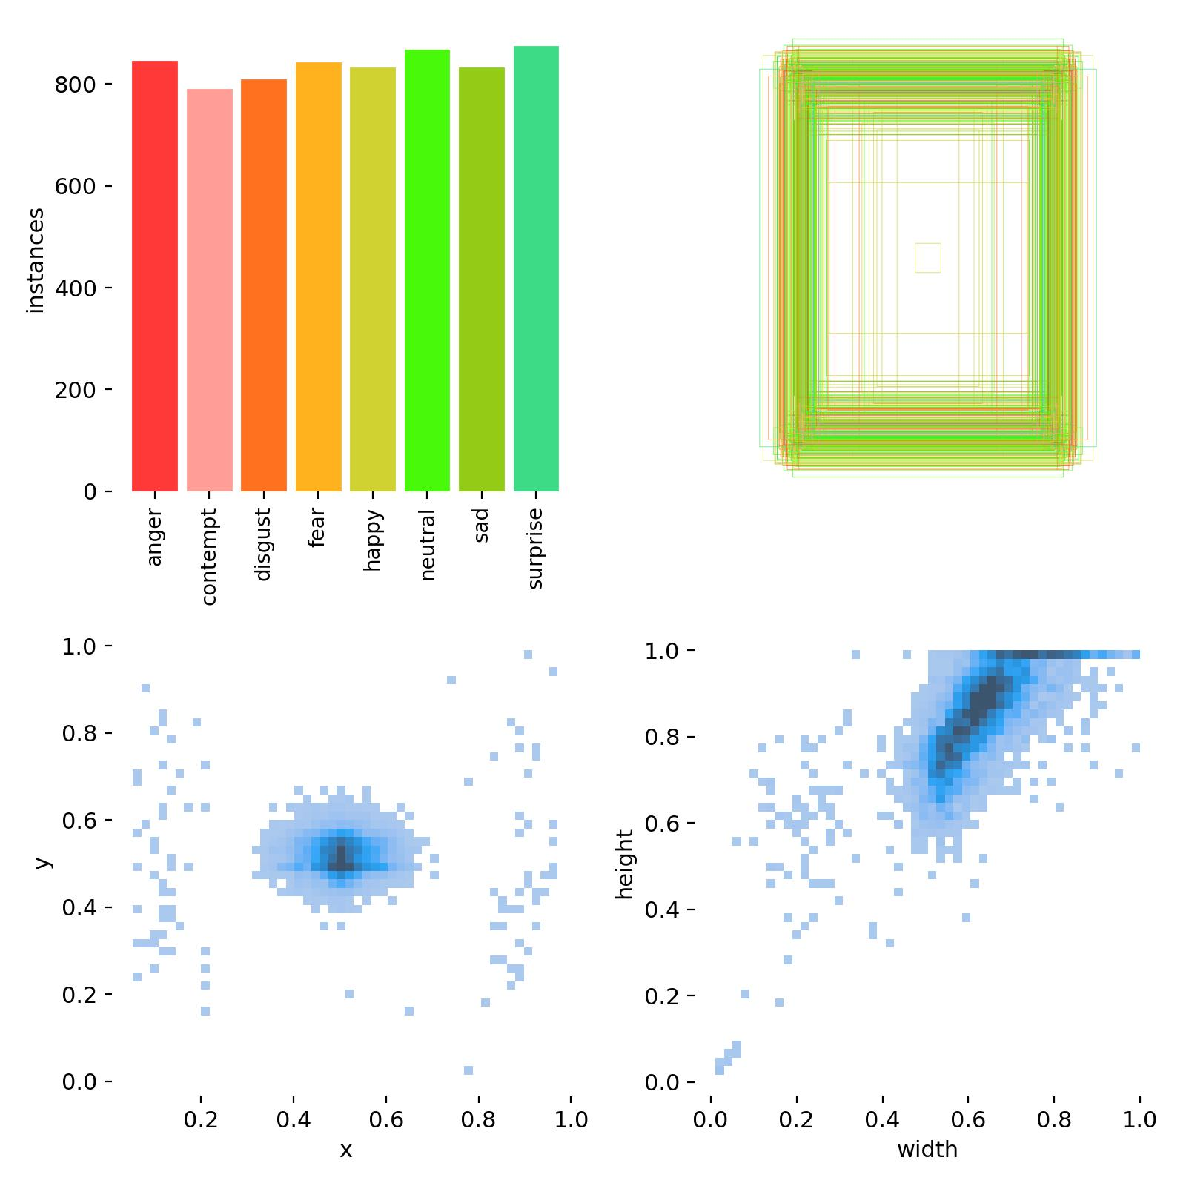

To ensure sustained model performance, continuous monitoring for model degradation and data drift is implemented. We utilize Evidently AI to detect significant shifts in data distribution and monitor predictive performance, helping to maintain the model's accuracy over time.

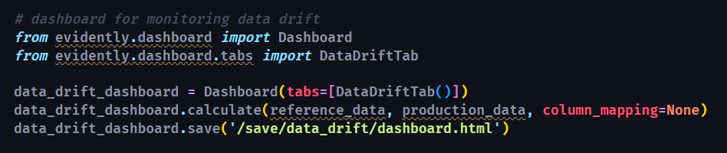

## 4.3. (10 pts) Continual Learning: CT/CD pipeline

The CT/CD pipeline ensures the model is continuously updated with new data, automatically retraining, and deploying without manual intervention. I used GitHub Actions to automate the retraining process whenever new data is available or periodically based on a schedule.

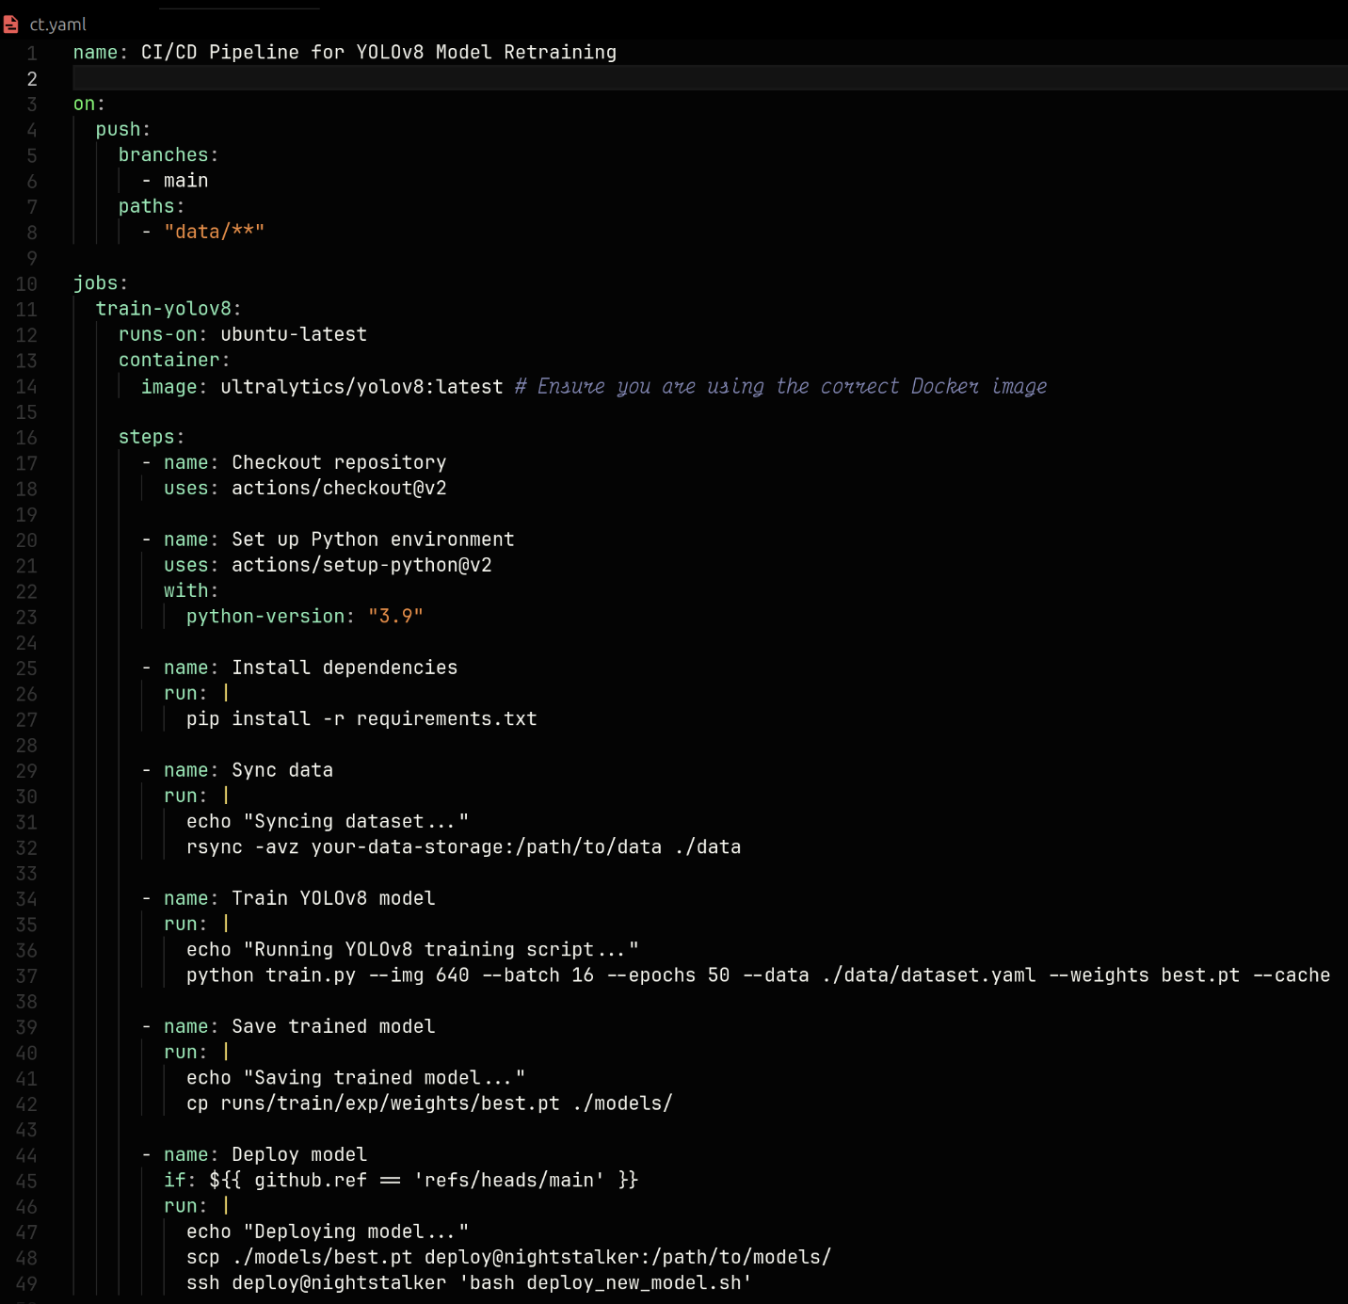

## 4.4. (3 pts) Pipeline orchestration

Apache Airflow orchestrates the workflow of the ML pipeline, managing tasks like data ingestion, preprocessing, model training, evaluation, and deployment. This coordination ensures that ML pipeline operates smoothly and efficiently.

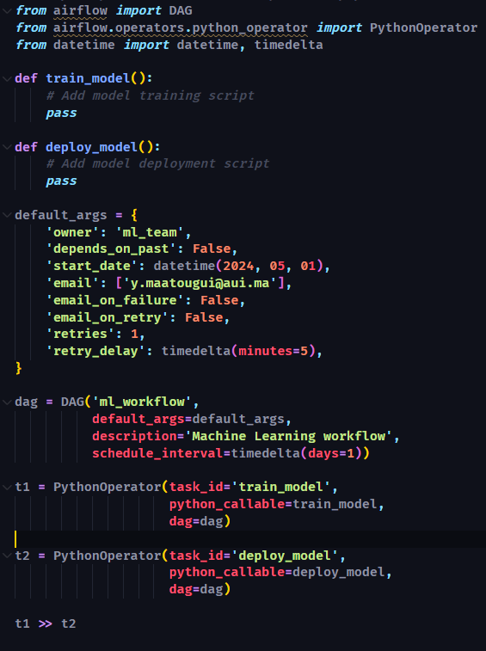

# 5. Responsible AI (milestone 8-optional, for later, 15% bonus)

## 5.1 Evaluation Beyond Accuracy

* **Audit Model for Bias:**
* **Model Explainability and Interpretability:**

# 6. Conclusion

* **Summary of Achievements:**

Developed a sophisticated ML system for face sentiment detection, leveraging advanced models and a robust pipeline, with high accuracy in detecting emotional states.

* **Lessons Learned:**

Emphasized the critical role of high-quality data and the impact of efficient data pipeline management in achieving high model performance.

* **Future Directions :**

Plan to enhance the model's capability to recognize a broader range of emotions and subtle expressions, integrate newer and more efficient ML models, and expand the application areas of the system.

# References

1. **TensorFlow Documentation**

TensorFlow is extensively used for model training and serving in your project. The official TensorFlow documentation provides comprehensive insights into its APIs, functionalities, and best practices.

* + Website: [TensorFlow](https://www.tensorflow.org/)

1. **TFX User Guide**

TFX (TensorFlow Extended) is critical for implementing the full ML pipeline in your project. This guide covers all components of TFX, including setup, usage, and examples.

* + Website: TFX User Guide

1. **Prometheus Documentation**

Used for monitoring system metrics within my project, Prometheus's documentation offers details on setup, configuration, and query execution.

* + Website: Prometheus

1. **Evidently AI**

For monitoring model performance and data distribution drift, evidently AI's tools are used. Their documentation provides guidelines on how to integrate their tools with existing machine learning pipelines.

* + Website: [Evidently AI](https://evidentlyai.com/)

1. **Apache Airflow Documentation**

As the orchestration tool in your project, understanding Airflow is crucial. This documentation provides information on how to define, execute, and monitor DAGs.

* + Website: [Apache Airflow](https://airflow.apache.org/docs/)

1. **GitHub Actions Documentation**

For implementing CI/CD pipelines that facilitate continual learning and deployment, GitHub Actions is a core component. This resource offers comprehensive guides on how to set up and manage workflows.

* + Website: [GitHub Actions](https://docs.github.com/en/actions)

1. **Docker Documentation**

Docker is used for creating, deploying, and running applications by using containers. The documentation provides a solid understanding of Docker commands and best practices.

* + Website: Docker

1. **Cassandra Documentation**

Since Cassandra is used for storing features, the official documentation can help understand its data model, query language (CQL), and setup procedures.

* + Website: [Apache Cassandra](http://cassandra.apache.org/doc/latest/)

1. **TensorFlow Serving with Docker**

For deploying models into production, TensorFlow Serving with Docker provides a robust and scalable framework. This article offers a deep dive into configuration and optimization.

* + Website: Serving TensorFlow Models